[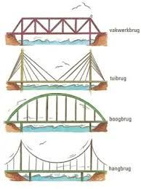](https://www.google.nl/url?sa=i&rct=j&q=&esrc=s&source=images&cd=&cad=rja&uact=8&ved=2ahUKEwiTp9qIwvfgAhUBKFAKHSODAZwQjRx6BAgBEAU&url=https%3A%2F%2Fwww.pinterest.com%2Fpin%2F740842207429911775%2F&psig=AOvVaw3v_gSnzmiPXV30rmF7aoYW&ust=1552304996829913)

[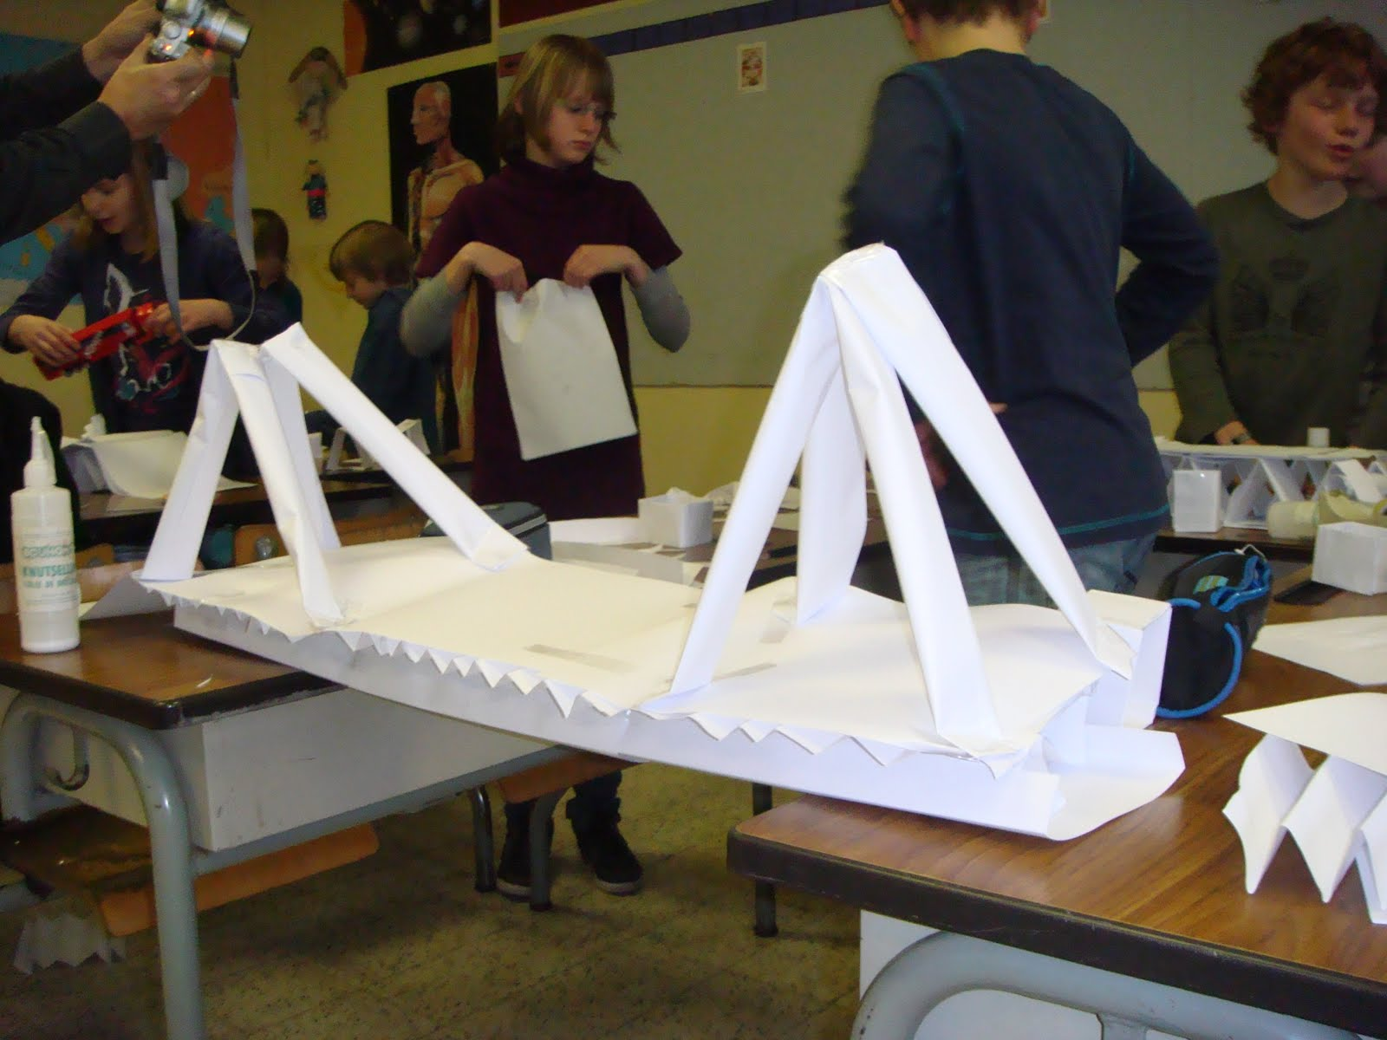](https://www.google.nl/url?sa=i&rct=j&q=&esrc=s&source=images&cd=&cad=rja&uact=8&ved=2ahUKEwiLwL-SwvfgAhVEYlAKHZXcD8QQjRx6BAgBEAU&url=http%3A%2F%2Fmieke-vandijck.blogspot.com%2F2011%2F05%2Fbruggen-bouwen.html&psig=AOvVaw3v_gSnzmiPXV30rmF7aoYW&ust=1552304996829913)

[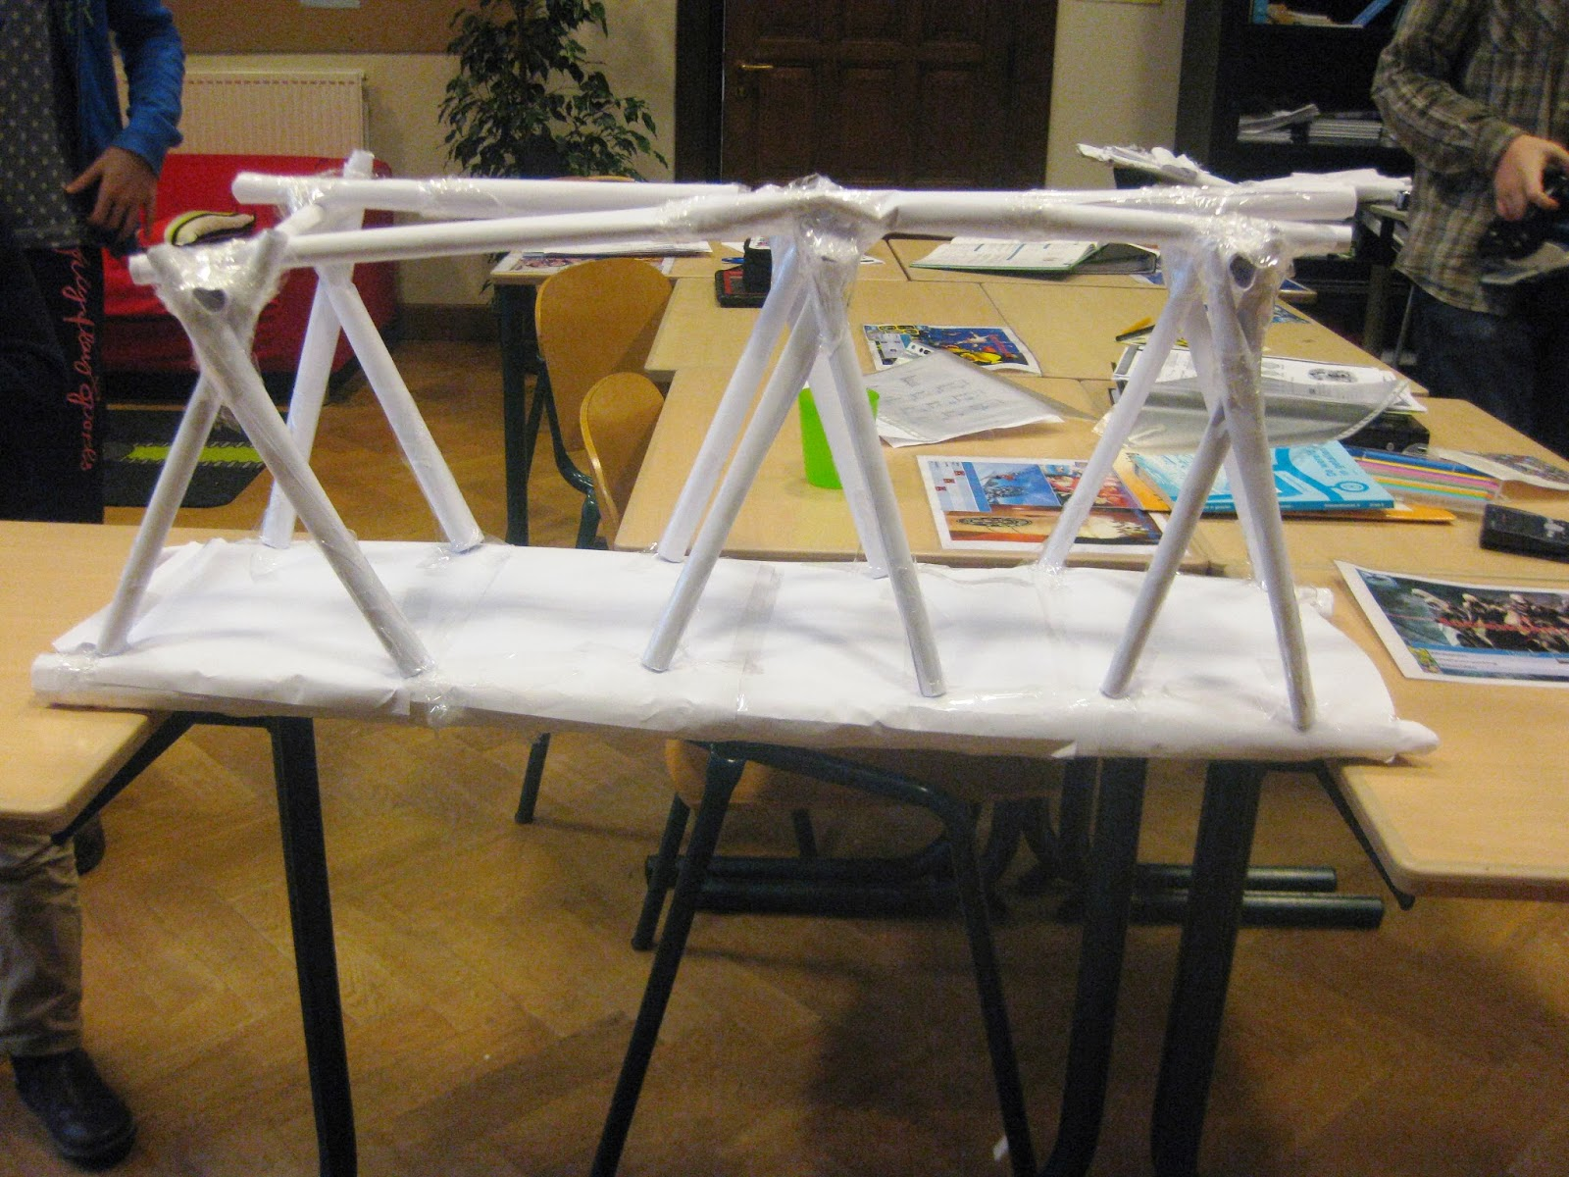](https://www.google.nl/url?sa=i&rct=j&q=&esrc=s&source=images&cd=&cad=rja&uact=8&ved=2ahUKEwiQ6s2awvfgAhVMI1AKHarrB-QQjRx6BAgBEAU&url=http%3A%2F%2Fwinforddenhaagpo.blogspot.com%2F2014%2F01%2Fonze-brug.html&psig=AOvVaw3v_gSnzmiPXV30rmF7aoYW&ust=1552304996829913)

[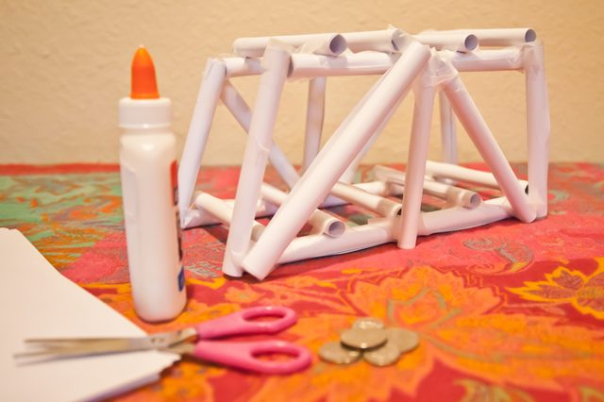](https://www.google.nl/url?sa=i&rct=j&q=&esrc=s&source=images&cd=&cad=rja&uact=8&ved=2ahUKEwj5gNvYwvfgAhVHK1AKHX29B8kQjRx6BAgBEAU&url=http%3A%2F%2Fwww.wikisailor.com%2Fhoe-maak-je-een-sterke-papier-brug.html&psig=AOvVaw3v_gSnzmiPXV30rmF7aoYW&ust=1552304996829913)